Problem Statement: There can be multiple customers, who can place multiple orders on the site. Now a sales person can handle these orders will distribute into multiple sales persons (One order will be assign to one salesperson only). So a sales person can have multiple orders of multiple customers

Ques 1: Create database.

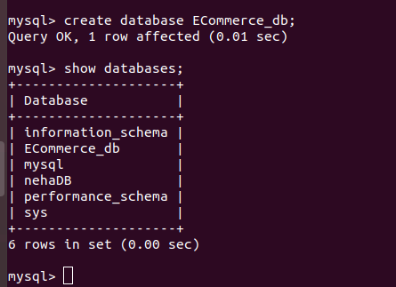
Sol 1:

Ques 2:Design Schema.

Sol 2:

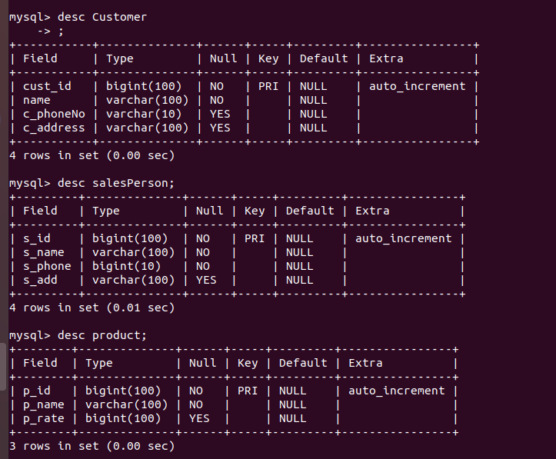

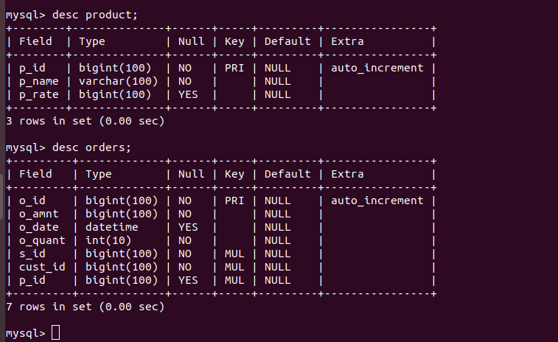

Ques 3:Create tables

Sol 3:
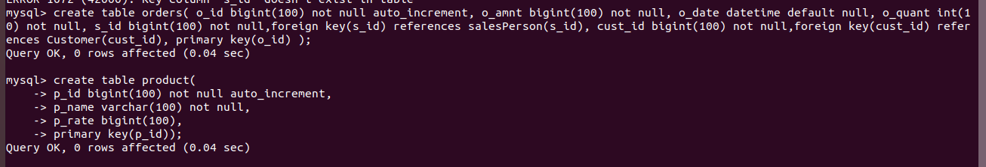
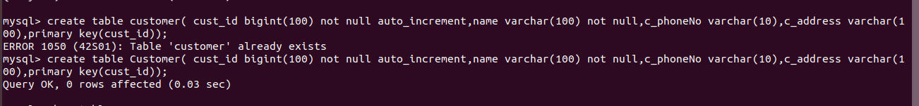

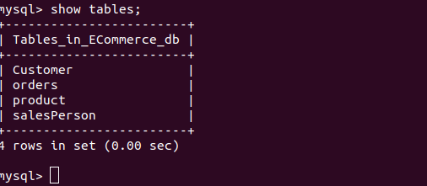

Ques 4:Insert sample data

Sol 4:

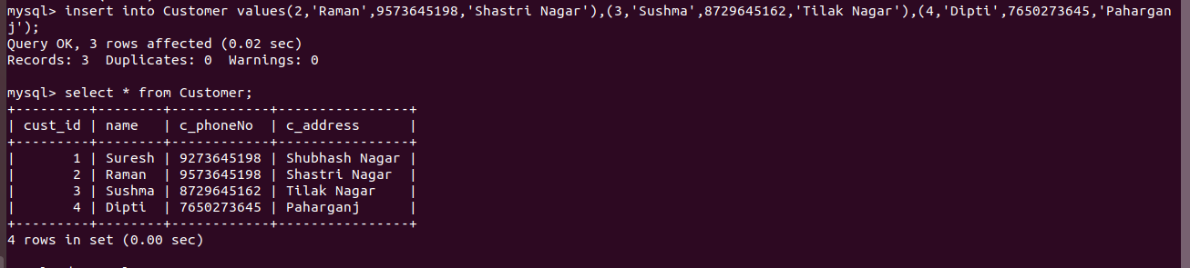
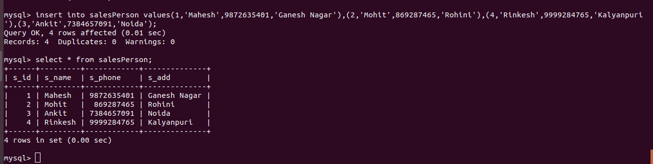
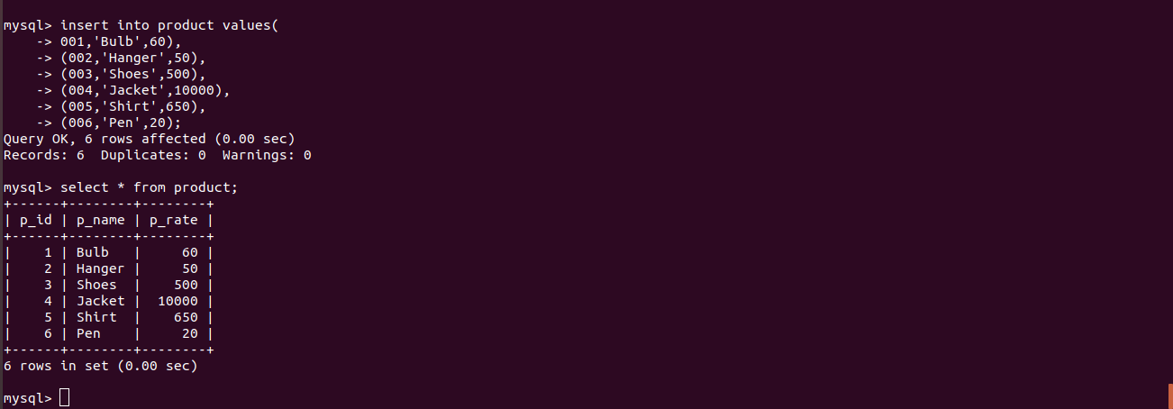

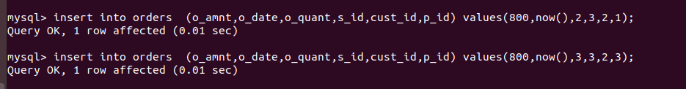
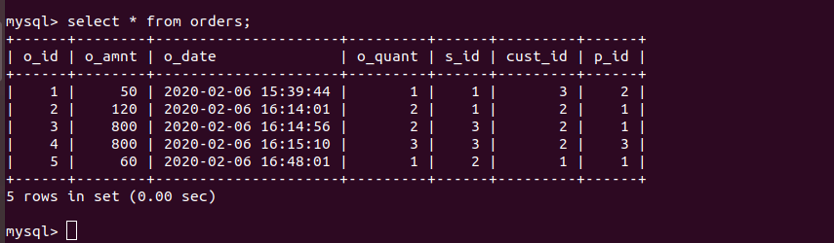

Ques 5:Find the sales person have multiple orders.

Sol 5:

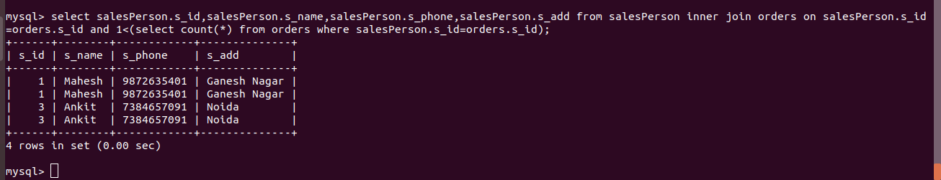

Ques 6: Find the all sales person details along with order details

Sol 6:

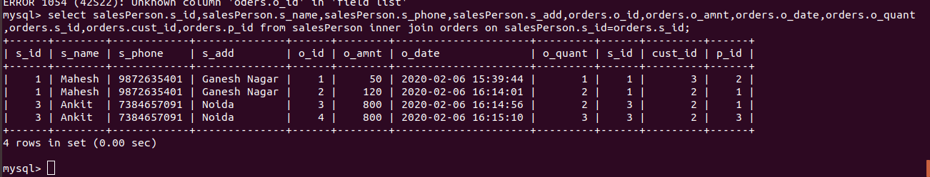

Ques 7:Create index

Sol 7:
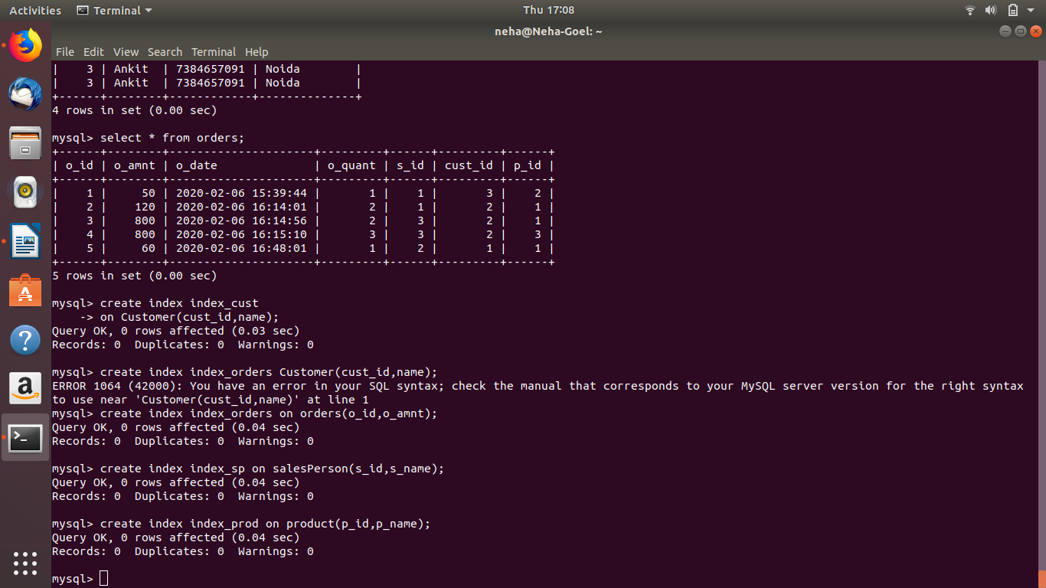

Ques 8: How to show index on a table.

Sol 8:

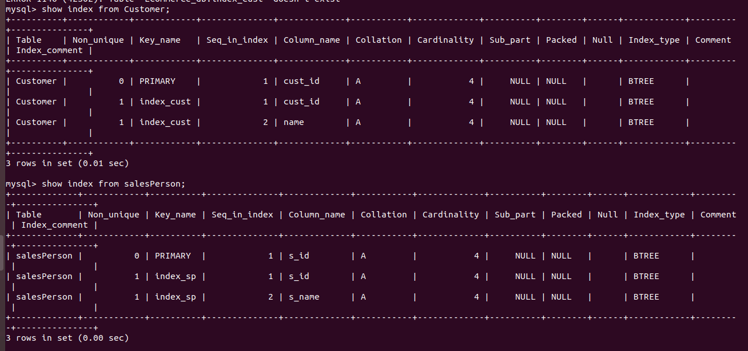
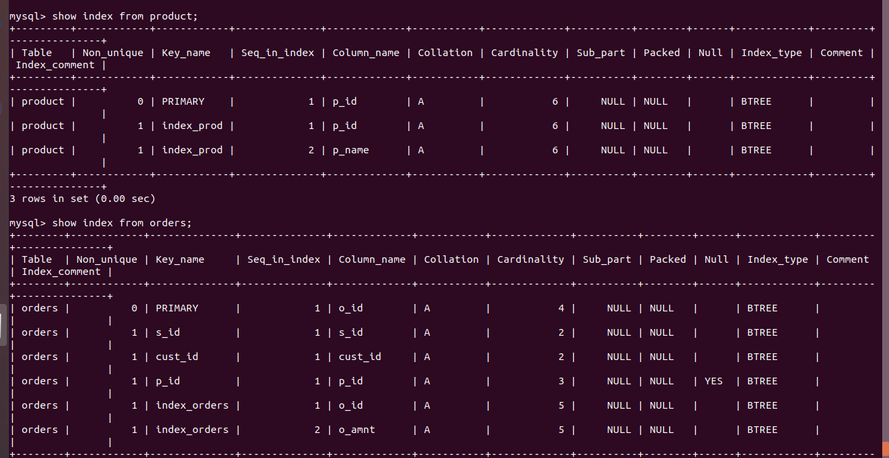

Ques 9:Find the order number, sale person name, along with the customer to whom that order belongs to.

Sol 9:
